

**OJT MANAGEMENT system**

**Software Requirement Specification**

– Ho Chi Minh, January 2022 –

**Table of Contents**

I. Overview 3

1. Introduction 4

2. System Functions 4

a. Screen Flow 5

b. Screen Details 6

c. User Authorization 8

d. Non-Screen Functions 8

3. Common Requirements 9

II. Functional Requirements 10

Web skeleton: 11

1. Student Feature 11

a. Login 11

b. Logout 11

c. Change password 11

d. Apply for a position 12

e. Upload CV 13

f. Confirm Application 13

g. Lookup company detail and job description 14

h.Browse for company 14

I. Update Profile 15

2. School Admin Feature 15

a. Login 16

b. View company list 16

c. View a specific company information 16

d. Edit a specific company information 17

e. Import OJT student list (with Excel) 17

f. View a specific student information 18

h. Export student list 18

i. Create OJT student account 18

3. Company Representative Feature 18

a. Create a Job for a company 18

b. View a specific student information 18

c. View student information list 18

d. Offer for a specific student 18

e. Submit student's OJT result 18

f. View company information 18

g. Edit company information 18

h. Change Password 18

# I. Overview

## 1. Introduction

OJT Management is a powerful yet simple to use, easy to simplify and visualize the internship process at universities and colleges. The system is expected to make the process of employ interns and get the result back to school more pleasurable and less time consuming.

<Link Context Diagram> <https://app.diagrams.net/#G1zX_hSZ-1ux4eAHI-ORrhdVfPQQXtmlZb>

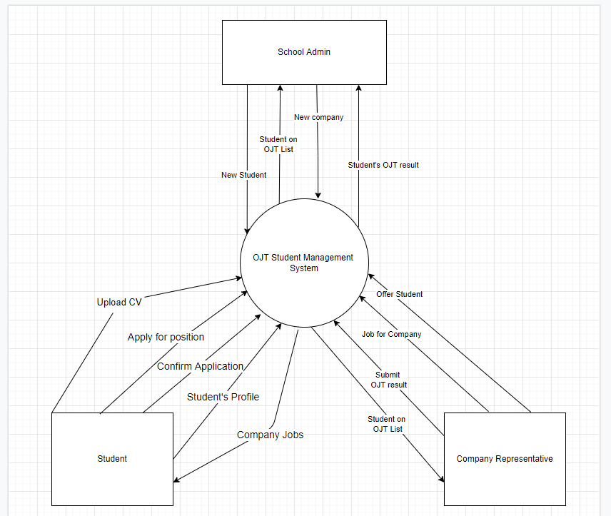

## 2. System Functions

### a. Screen Flow

Link figma <https://www.figma.com/file/FNH7QbrJu6UJcy5TxqRXYd/OJT-Management?node-id=0%3A1>

Link <https://app.diagrams.net/#G1qrJMeBg6jNl4CTK37-24IsFLZ0Ow2BnD>

* Role Student

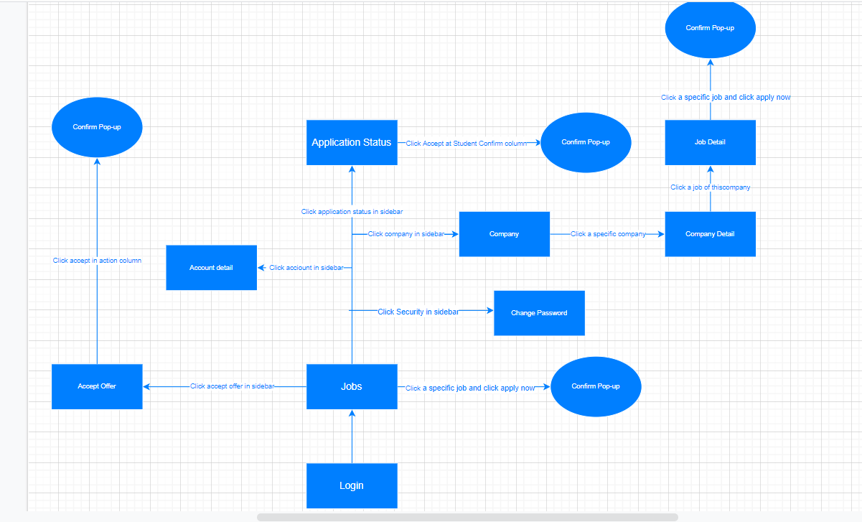

* Role School Admin

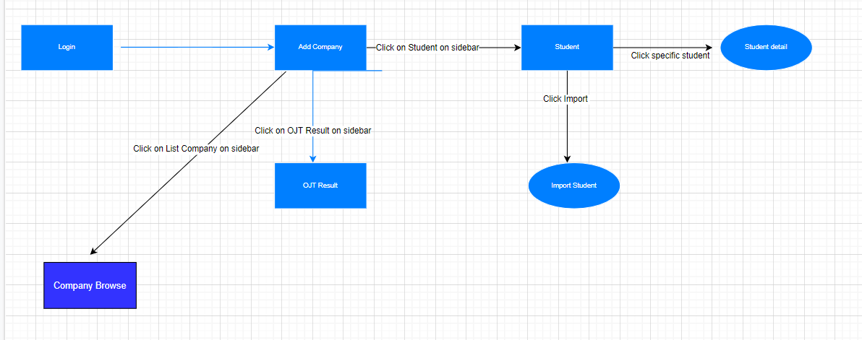

* Role Company

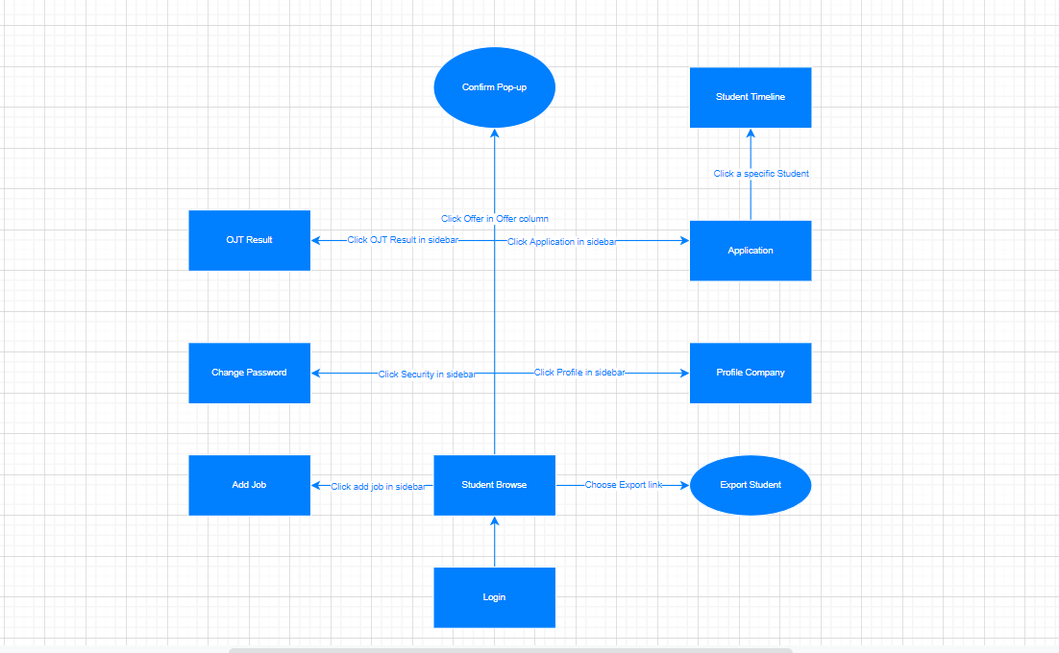

### b. Screen Details

|  |  |  |  |
| --- | --- | --- | --- |
| **#** | **Feature** | **Screen** | **Description** |
| 1 | Public Feature | Login | All stakeholder login by the Login Site and System will authorization to their page. |
| 2 | Public Feature | Change password | All user change password by go to the security tab in sidebar. |
| 3 | Student Feature | Jobs | Showing list of jobs for Students to browse. Students can Click specific job and click apply, pop-up to confirm will show up for confirmation. |
| 4 | Student Feature | Account detail | Details about login student. Student can edit profile on this screen. |
| 5 | Student Feature | Accept Offer | Accept Offer from company. Pop-up to confirm will show up for confirmation. |
| 6 | Student Feature | Company | Showing list of companies. |
| 7 | Student Feature | Company Detail | Details about Company: list of available jobs, basic info, Key Skills, Overview, ... |
| 8 | Student Feature | Job Detail | Showing detail of the job from the company. When click apply pop-up to confirm will show up for confirmation. |
| 9 | Student Feature | Application Status | Showing status about jobs from student applying: Student Confirmed, School Denied, Company Accept, …. Click accept at “Student Confirmed” pop-up to confirm will show up for confirmation. |
| 10 | School Admin Feature | Add Company | Create new company. |
| 11 | School Admin Feature | Student | Show students list. Can import students from file, see student detail by click on specific student and edit information of student. |
| 12 | School Admin Feature | OJT Result | Show student list. Can change result PASSED or NOT PASSED of students |
| 13 | School Admin Feature | Company Browse | Show companies list. Can manage companies' information. |
| 14 | Company Representative Feature | Student Browse | Show students list. Click on “Offer” to send offer to student, pop-up to confirm will show up for confirmation.  Can export students. |
| 15 | Company Representative Feature | Add Job | Add jobs for students to apply. |
| 16 | Company Representative Feature | Profile Company | Details about login company. |
| 17 | Company Representative Feature | OJT Result | Show student list. Submit student’s OJT result. |
| 18 | Company Representative Feature | Application | Showing status about jobs from student applying: Student Confirmed, School Denied, Company Accept, …. |
| 19 | Company Representative Feature | Student Timeline | Showing Student Timeline, Company can approve/deny student’s OJT applications. |

### c. User Authorization

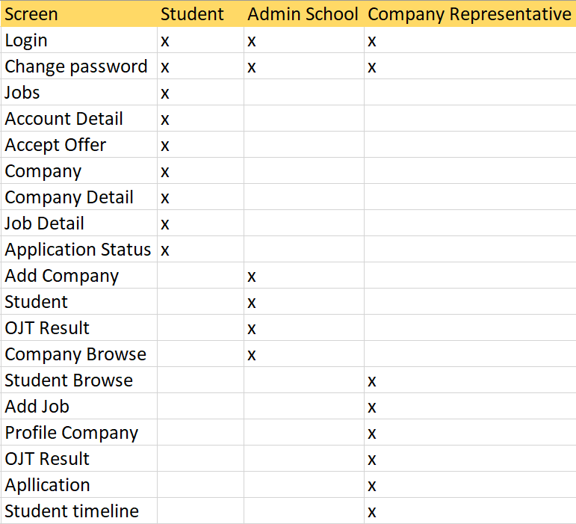

In which:

* Role1: Student
* Role2: School Admin
* Role3: Company Representative

### d. Non-Screen Functions

|  |  |  |  |
| --- | --- | --- | --- |
| **#** | **Feature** | **System Function** | **Description** |
| 1 | Send Notification Email |  | Email will be sent automatically in these scenarios:   * Student Apply for job * Company accept application * Student accept offer * User account created |

## 3. Common Requirements

* User Interface:

The user interface has to friendly, easy to use and usable

* Functional Requirements:

Student (Authentication is required)

Student only go to OJT in one company, therefore they just confirm one application/offer

· Upload CV (Can upload many cv for many types of jobs)

· Apply for a position(s)

· Confirm application(s)/ Accept offer (only one)

· Lookup company detail and job description

· Browse for company

· Change password and profile

School Admin (Authentication is required)

· Manage company information

· Manage Student’s OJT results

· Import OJT students list (with excel)

· Browse for student info

· Export student list

· Create Accounts for Student (by import OJT students list)

. Create Accounts for Company

Company Representative (Authentication is required)

· Create Job for company

· Approve/Deny OJT applications

· Browse for student info

· Offer for student(s)

· Submit student’s OJT result

· Change password and profile

# II. Functional Requirements

## Web skeleton:

* **Link Figma**: <https://www.figma.com/file/FNH7QbrJu6UJcy5TxqRXYd/OJT-Management?node-id=0%3A1>
* **Link Template** <https://github.com/minimal-ui-kit/material-kit-react>

## 1. Student Feature

### a. Login

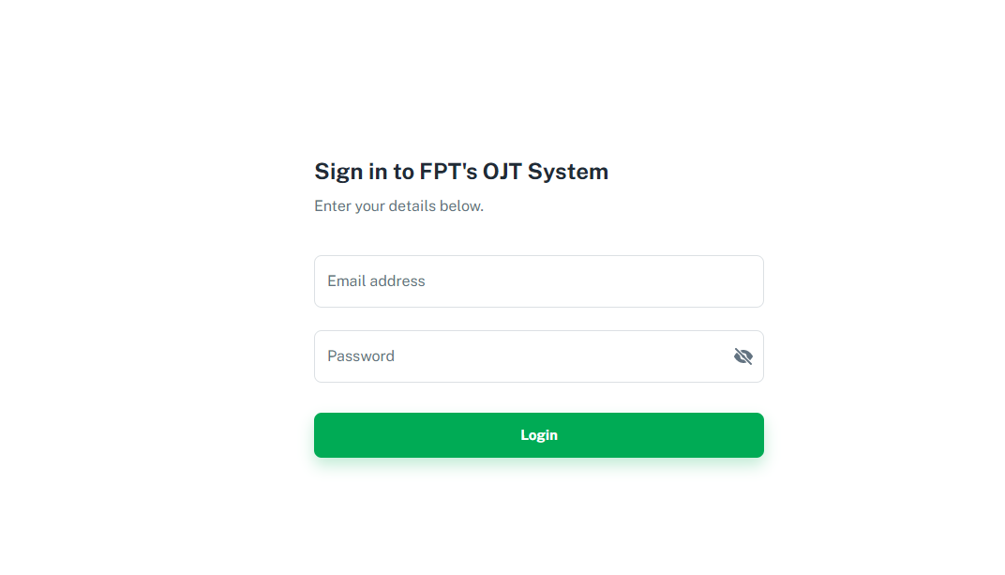

Students access system through browser have to

* Log in enter email & password and click sign in.
* System will redirect to Student's page

### b. Logout

Student click on “Logout” to log out

System will redirect to login page after student click on logout

### c. Change password

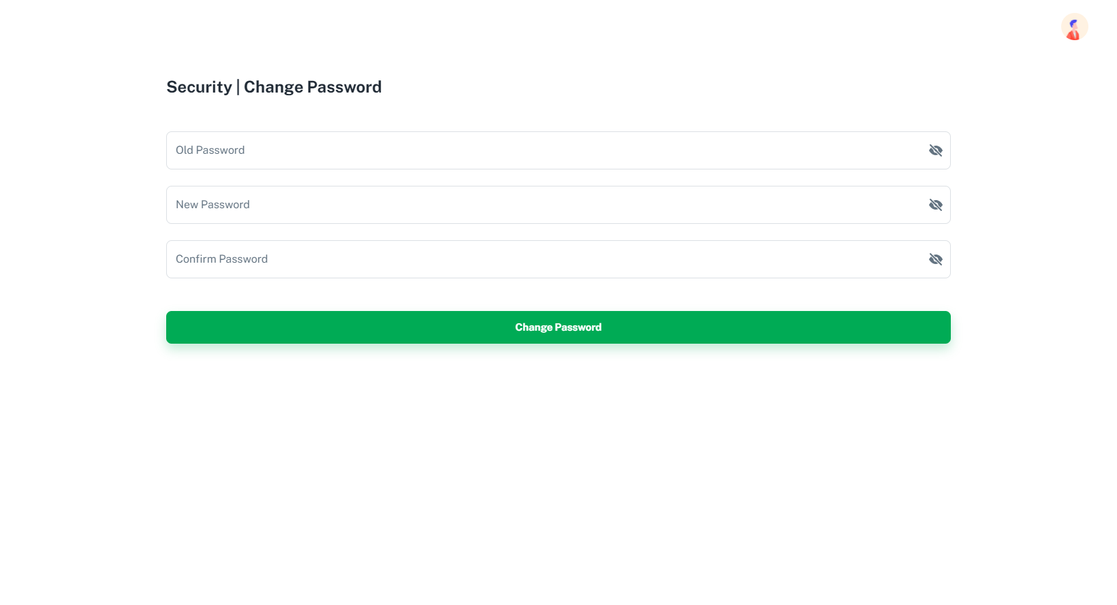

To change password, student

* Click on Security in sidebar
* Enter password and confirm password
* Click Update and the password will be changed

### d. Apply for a position

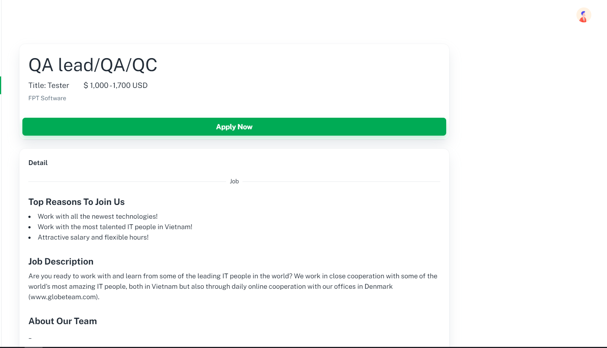

Student can apply for many positions and each position can upload a CV. (CV in different position can be different)

To Apply for a position, student

* Click on Jobs on sidebar
* A list jobs will show in the left and their detail will show in the right of the screen like above picture
* Click on a specific job, and click “APPLY NOW” on the right screen
* A pop up will show, read *“e. Upload CV”* for more information

### e. Upload CV

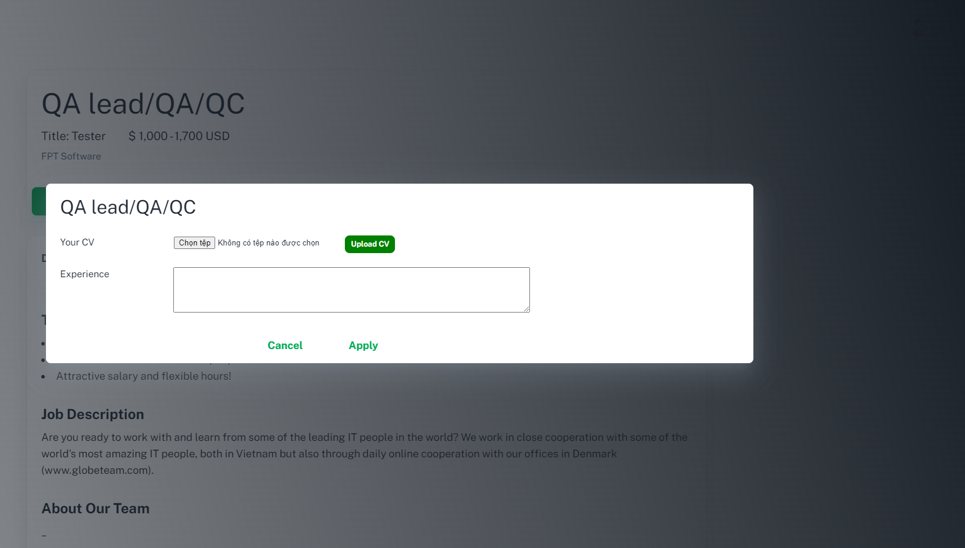

Student can apply for many positions and each position can upload a CV. (CV in different position can be different)

After do the steps written in “*d. Apply for a position*”, a pop up will show like above picture. Student

* Enter name, major, skills
* Click “Choose File” to upload cv
* Click button “Send my CV”

### f. Confirm Application

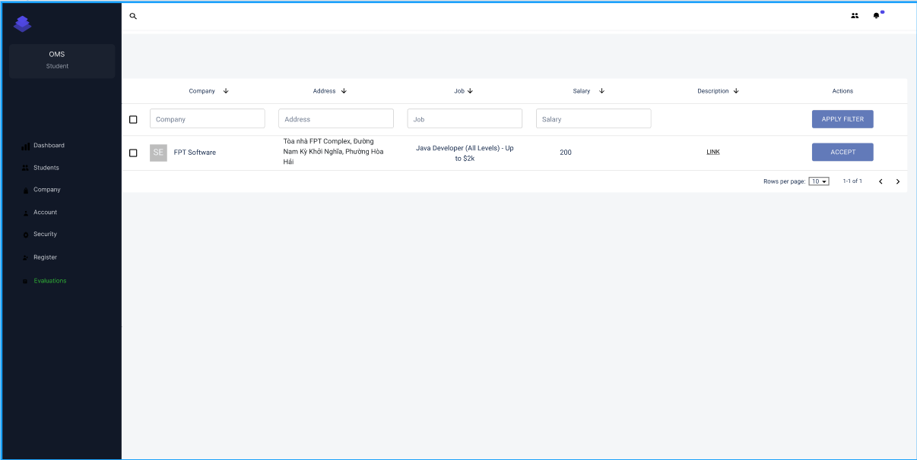

After being confirmed by the company

* Click on Jobs on sidebar
* Click button “ACCEPT” to Confirm Application.

### g. Lookup company detail and job description

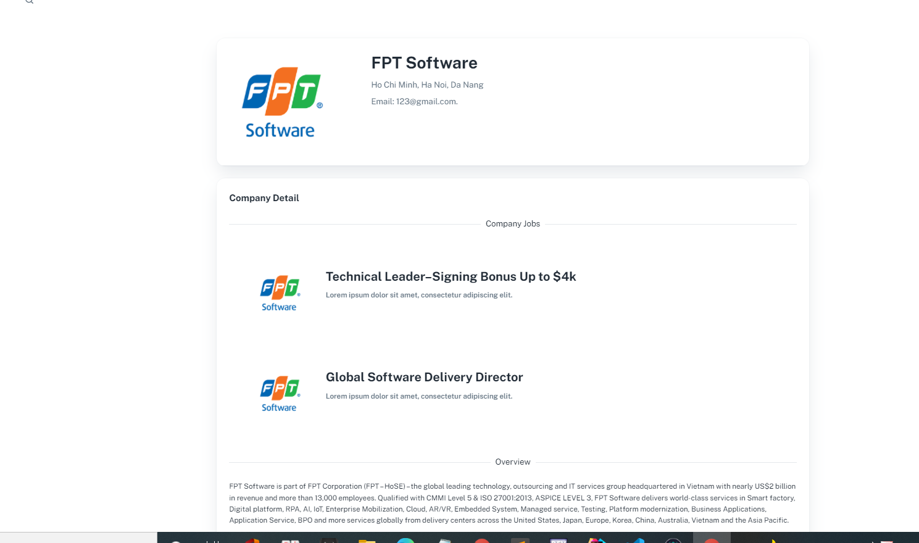

To Lookup company detail and job’s description :

* Click on the company in list company and then view detail

### h.Browse for company

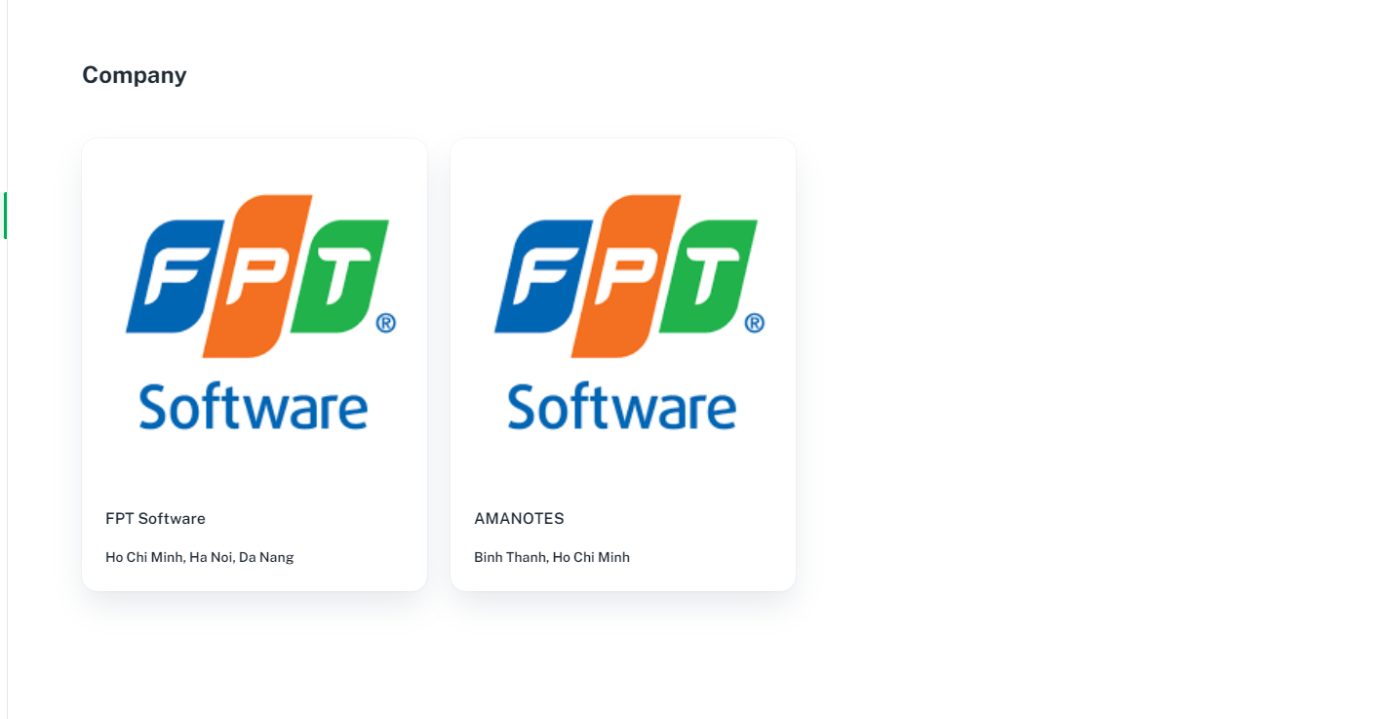

* Click “Company” on side bar to browse for company

### I. Update Profile

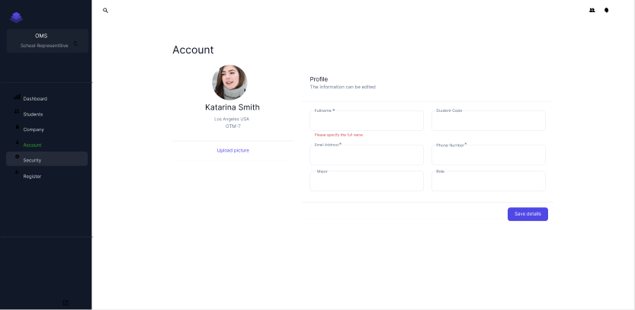

To Update Profile :

* Click on “Account” on sidebar to update
* After fill the blank click on “Save Detail”

## 2. School Admin Feature

### Login



School Admin access system through browser have to

* log in by google or
* enter email & password and click sign in.

### b. View company list

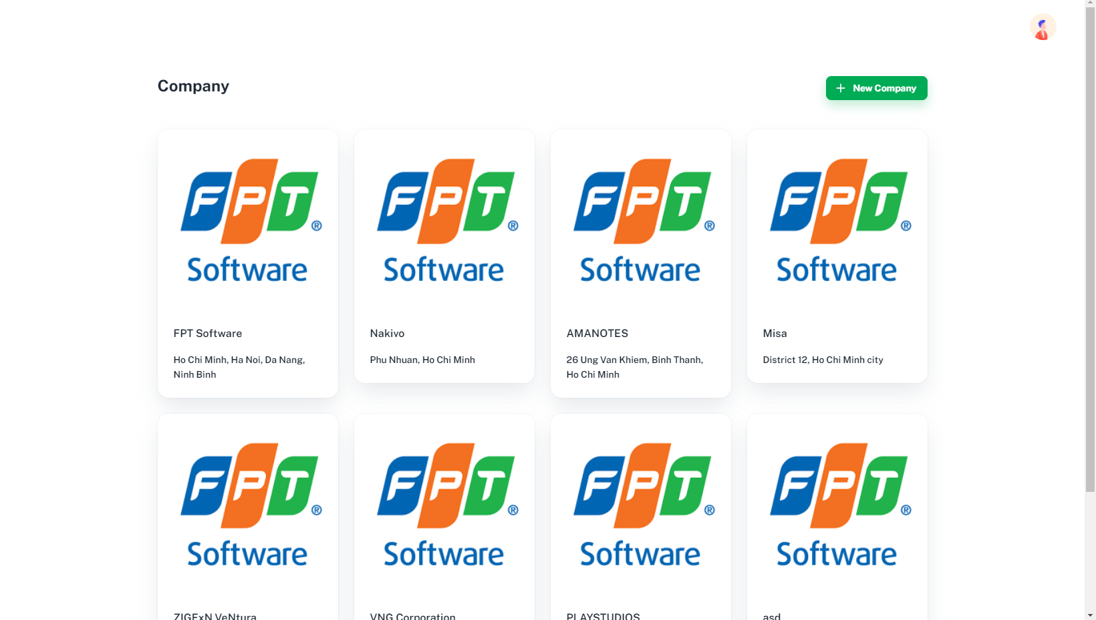

To view company list :

- Click “Company” on side bar to View

### c. View a specific company information

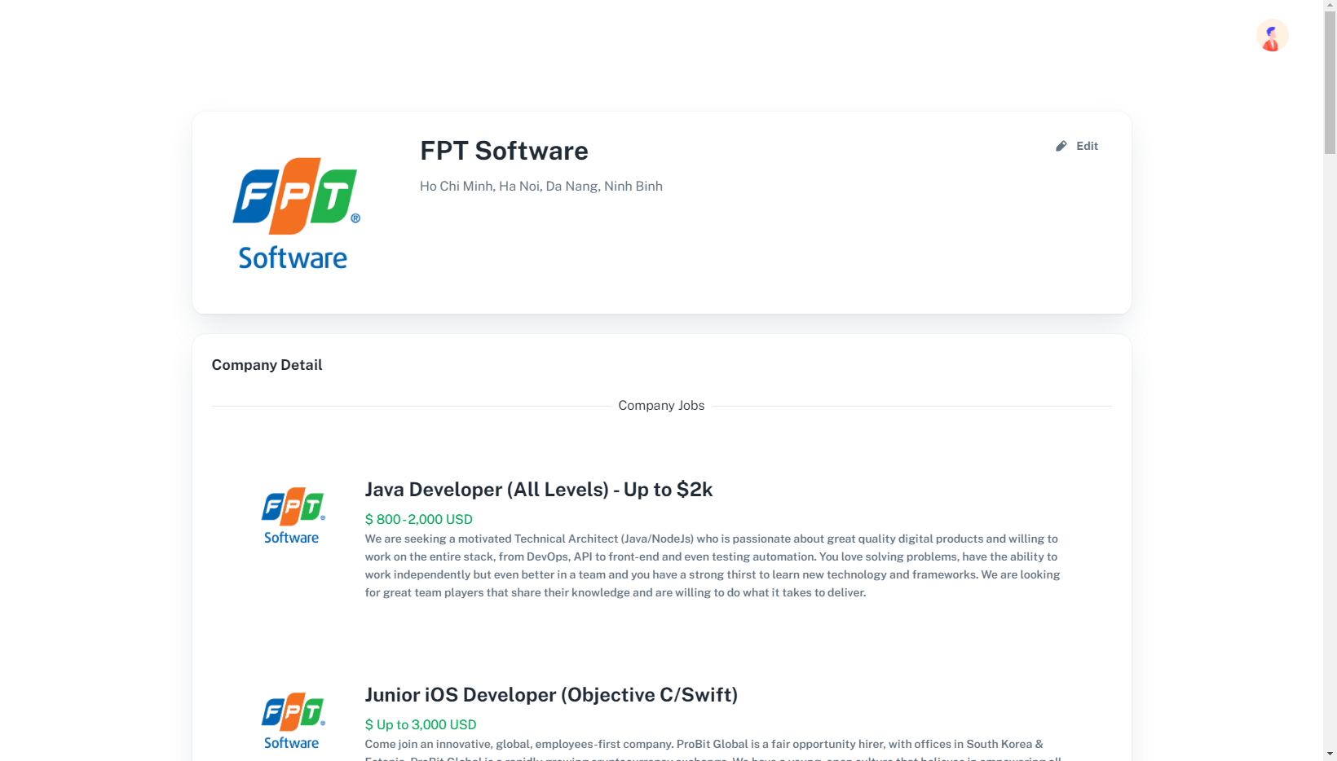

To view the detail of company

* Click on a specific company’s logo in the company list.

### d. Edit a specific company information

To edit company information

* Click on edit at company information page

### e. Import OJT student list (with Excel)

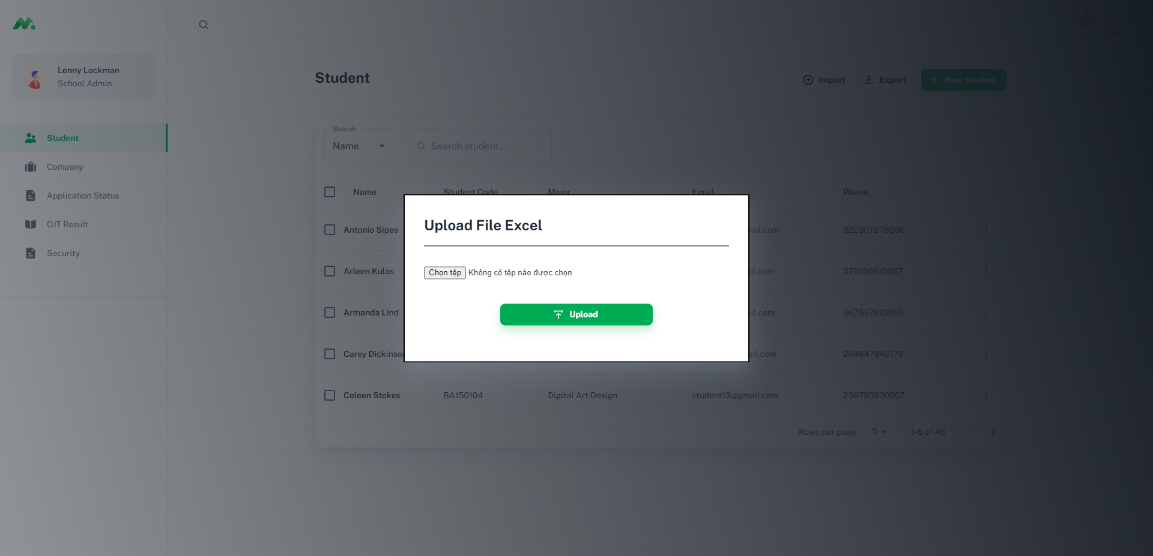

To import OJT student list

* Click on import button on top right of the screen
* Pop-up to import excel file will show up

### f. View a specific student information

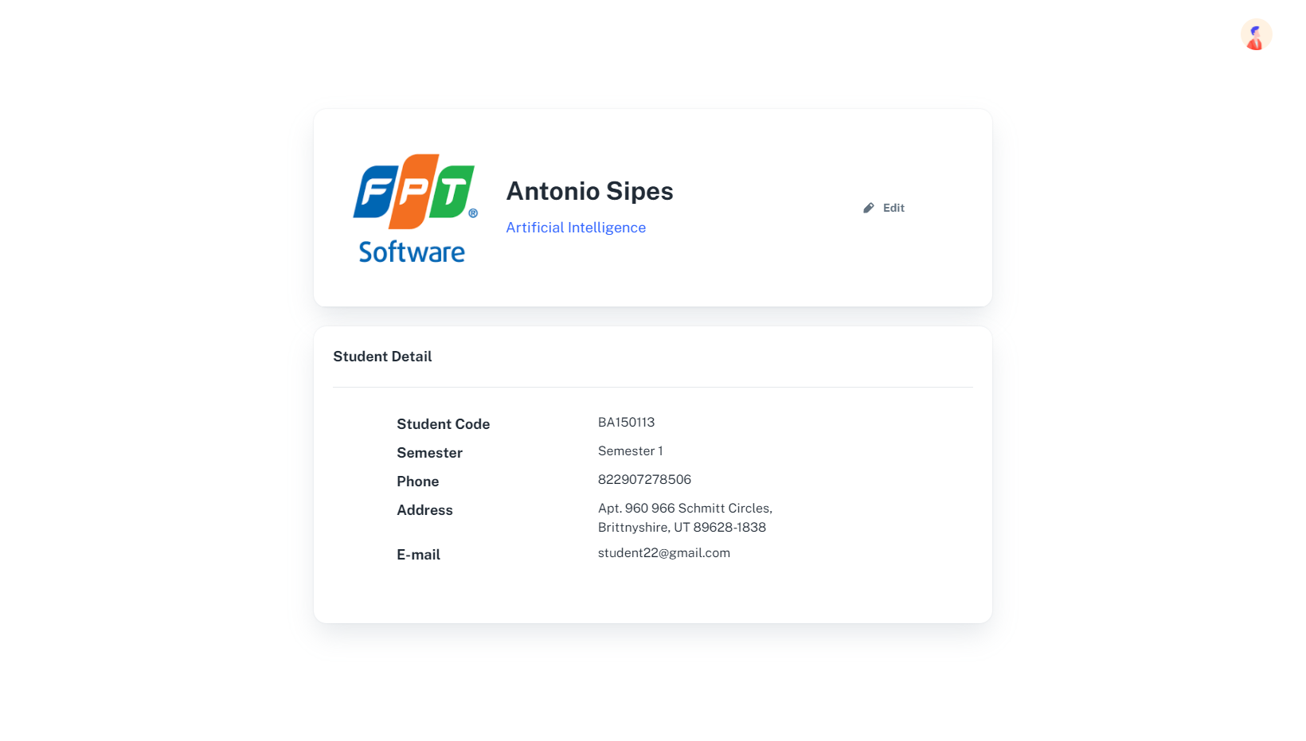

To view a specific student

* Click on row have student name at student list page

### h**. Export student list**

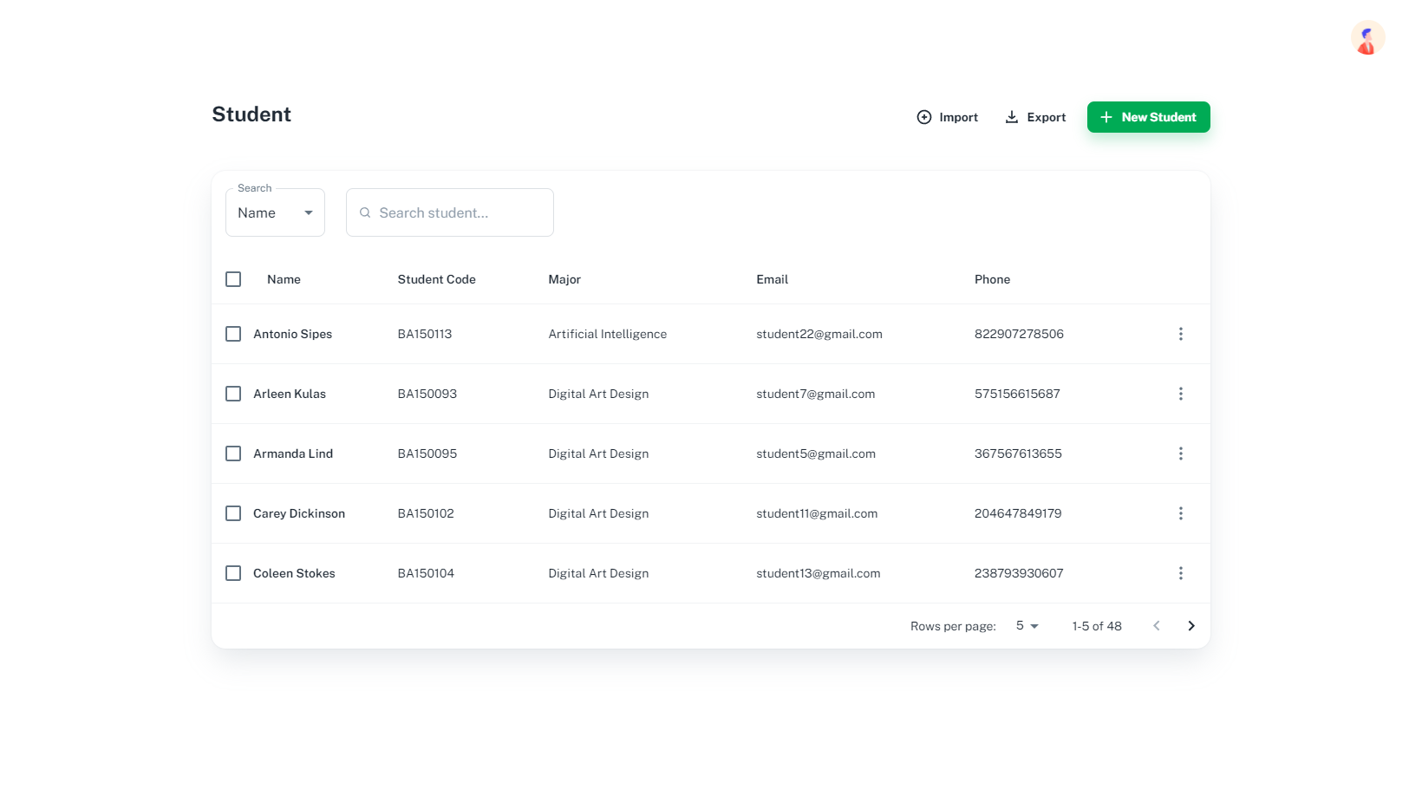

To export student list:

* Click on export button on top of the student table on table screen
* The file will be automatically downloaded

### **i. Create OJT student account**



To Create OJT student account:

* Click on the import button on top of the student table
* Account will be automatically created by the system and send to email of each individual student

## 3. Company Representative Feature

### **Create a Job for a company**

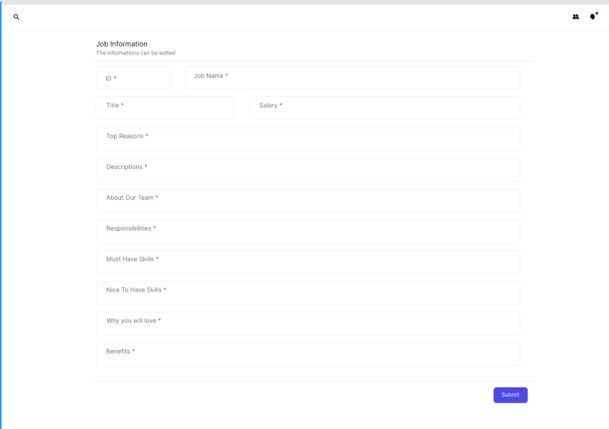

To Create job for company:

* User click on the create job tab on the sidebar on the left of the screen
* Fill out all the necessary information on the screen and click submit
* The job will be created and list on the job browse screen

### **View a specific student information**

* Function trigger: To seeing a specific student information Company Representative click for a specific student to view detail information of this student
* Function description: This function spent for Company Representative to see the detail of a specific student on the list student.

To see detail a specific student information:

* Click on student tab on sidebar and a student list will appear.
* Double click a specific row have the name of the student want to see detail information and Student information detail screen will appear.
* Screen layout:



### **View student information list**

* Function trigger: Company Representative must login first and go to the Student tab to see the list of Students
* Function description: This function spent for Company Representative to see the list of the OJT student list

To see the list of the student:

* After login in the welcome page Company Representative click to tab Student on sidebar
* The Student List Page will be redirect to
* Screen layout:

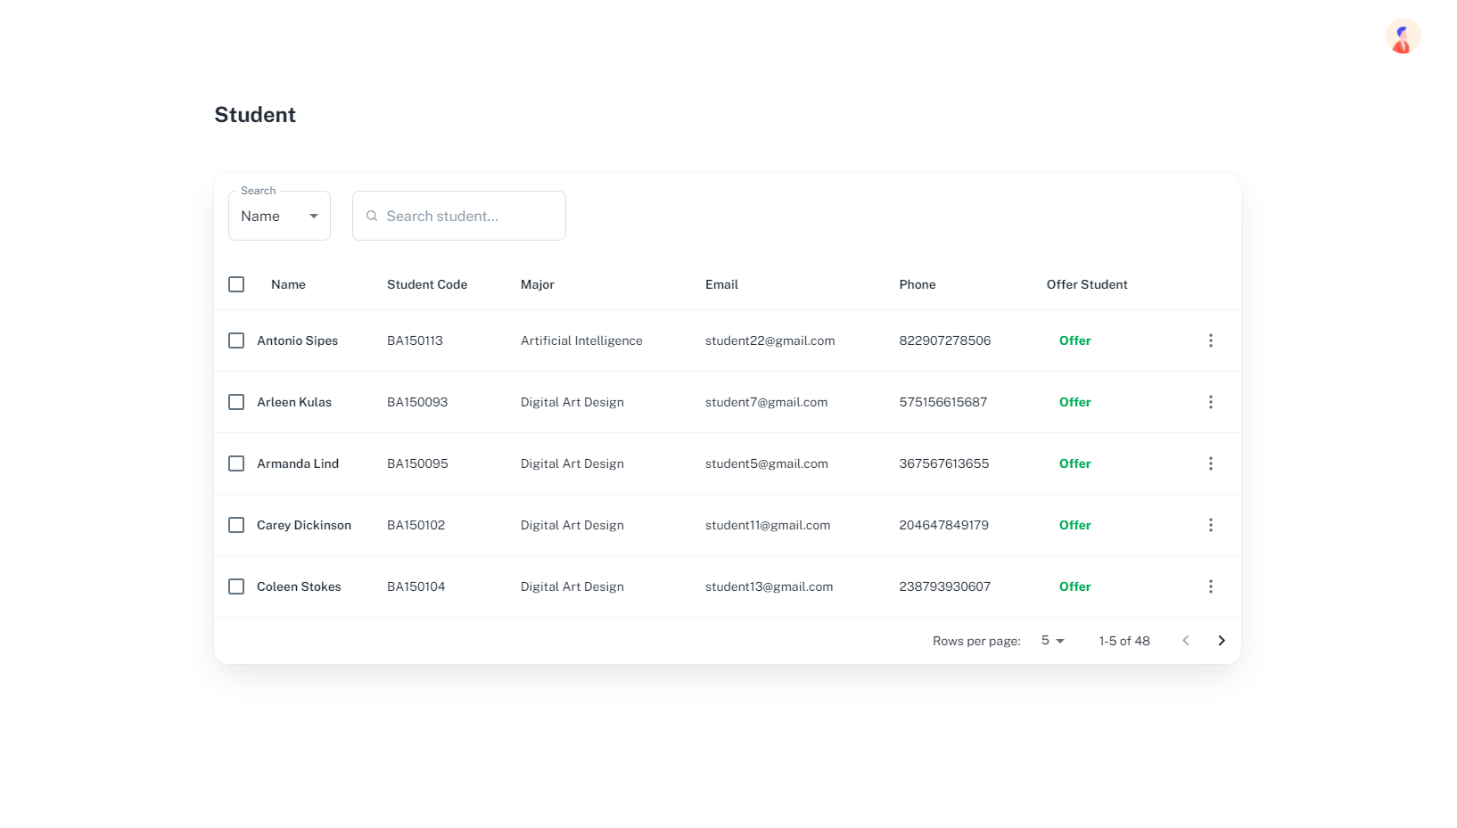

### **Offer for a specific student**

* Function trigger: Company Representative must login first and go to the Student tab to see the list of Students. On this page Company Representative can offer a student that they want to offer.
* Function description: This function spent for Company Representative to offer a student that they want to offer. On the list of student page will have a button offer on every row of student. And they can offer a student by click on Offer button

To offer a student:

* After login in the Welcome page Company Representative click on the Student tab on side bả and the Browser will be redirected to Student List page.
* In the Student List page on every row of student has an Offer button. Click on Offer button that Company Representative want to offer.
* Screen layout:



### **Submit student's OJT result**

* Function trigger: Company Representative must login first and …
* Function description: This function spent for Company Representative to submit OJT result of student to School.

To submit the OJT Result:

* Screen layout:

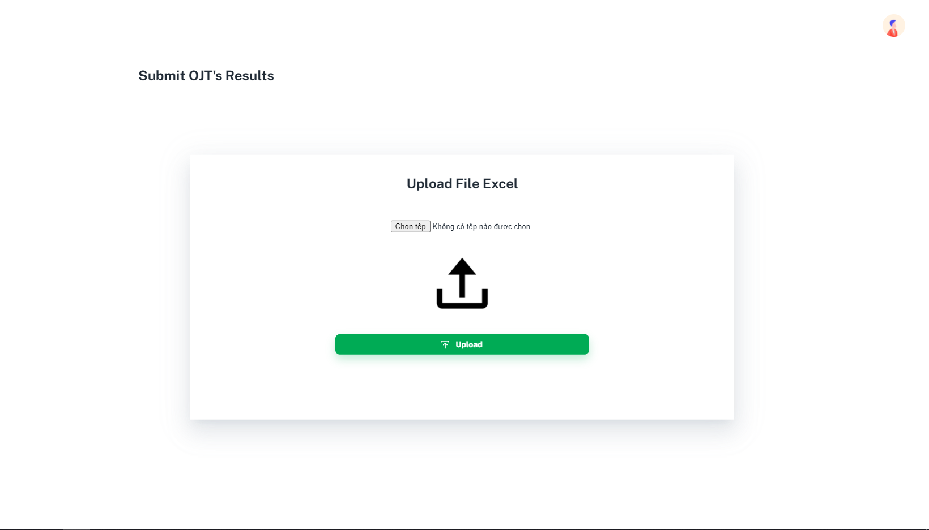

### **View company information**

* Function trigger: Company Representative must login first and go to the Account tab in sidebar
* Function description: This function spent for Company Representative to see their information.

To see company information:

* After login in the welcome page Company Representative click to tab Account on sidebar
* The Company Information Page will be redirect to
* Screen layout:

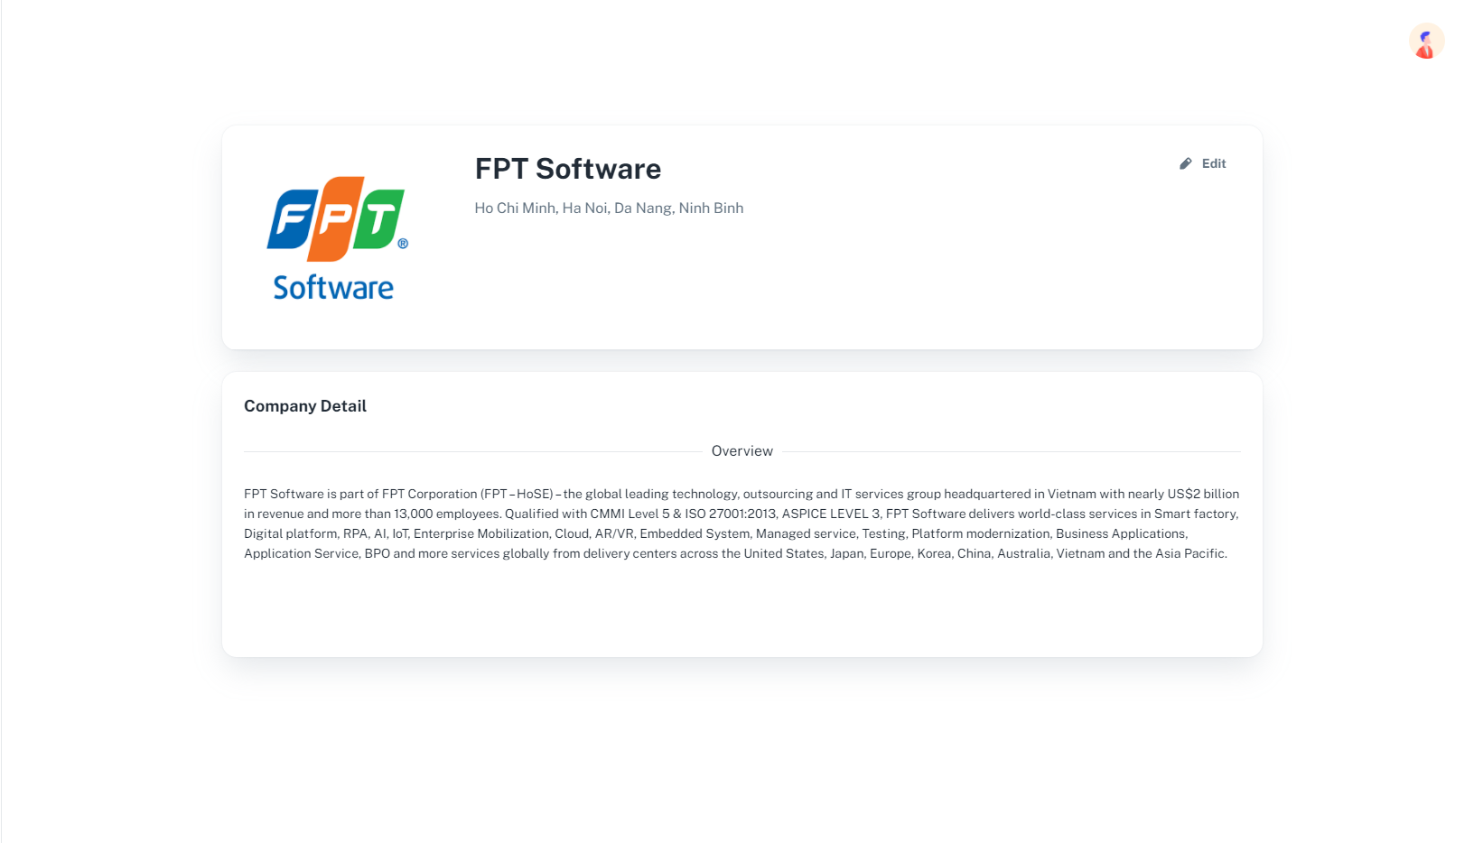

### **Edit company information**

* Function trigger: Company Representative must login first and go to the Account tab in sidebar
* Function description: This function spent for Company Representative to edit their information.

To see company information:

* After login in the welcome page Company Representative click to tab Account on sidebar
* The Company Information Page will be redirect to and click on Edit button on Screen
* The Layout will allow edit their information
* After Edit click on Save to Save every information or Cancel to keep the information not change
* Screen layout:

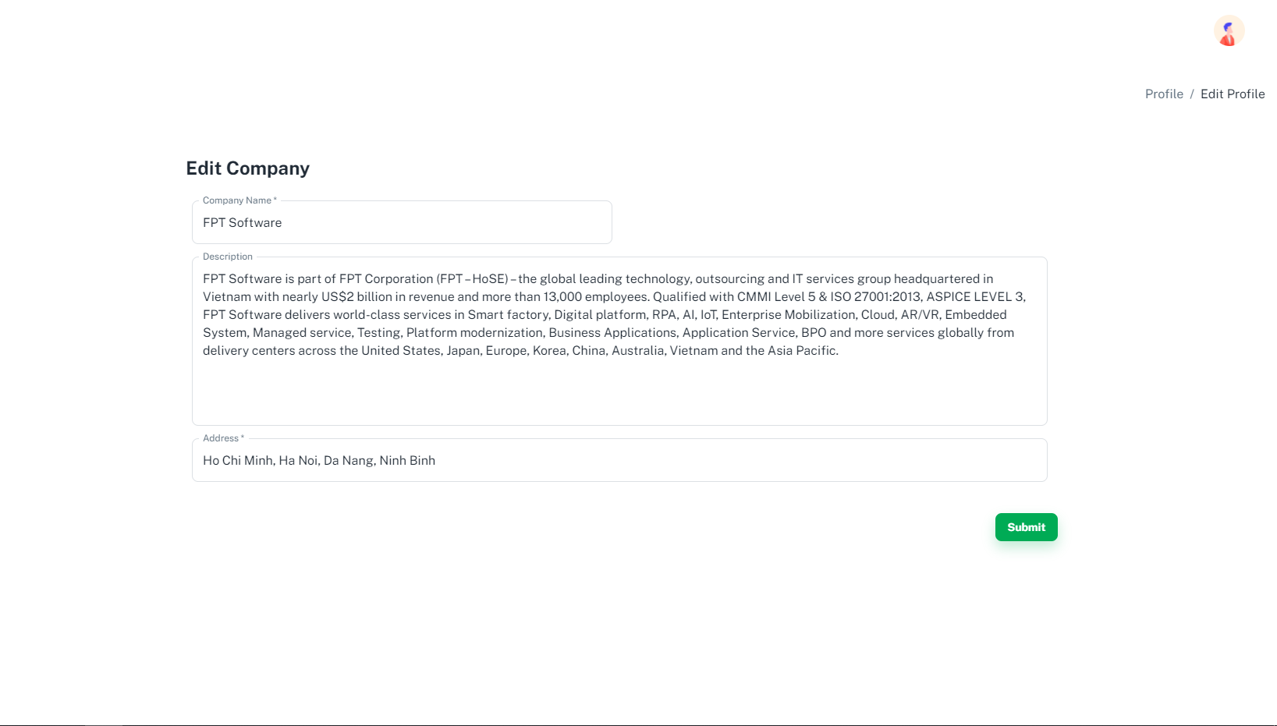

### **Change Password**

* Function trigger: Company Representative must login first and go to the Security tab in sidebar. The password change must be:
* 6-24 characters
* Do not contain special character
* Have at least an uppercase and a number
* Do not like the current password
* Function description: This function spent for Company Representative to change password.

To change password:

* After login in the welcome page Company Representative click to tab Security on sidebar
* The Security Page will be redirect to, click to Change password to Change their password.
* After input old password, new password, and confirm new password and all field have valid. The password will be changed as soon as click to Update button.
* Screen layout:



### **Verify OJT Application**

* Function trigger: Company Representative must login first and go to the Application tab in sidebar.
* Function description: This function spent for Company Representative to accept student application.

To accept application:

* After login in the welcome page Company Representative click to tab Application Status on sidebar
* The Application Status Page will be redirect to, click to more menu student want to accept, click Accept in menu to Accept their application.
* Screen layout:

